Order Of Service

Singing: Psalm 90—CW page 99

Reading: Psalm 43

Opening Hymn: CW 260

Reading: Acts 2:22-28

Request Hymn: CW Supplement 754

Reading: John 10:22-30

Sermon Hymn: CW 363

Sermon Text: Song Of Solomon 7:4

Holy Violence

Prayer

The Apostles’ Creed, TLH page 12

Holy Communion

The Lord's Prayer

The Blessing

Closing Hymn: CW 496

* * * * * * * * * * *

Bible Study: Lambs: Burr Oak
Sheep: Romans 1:16-23
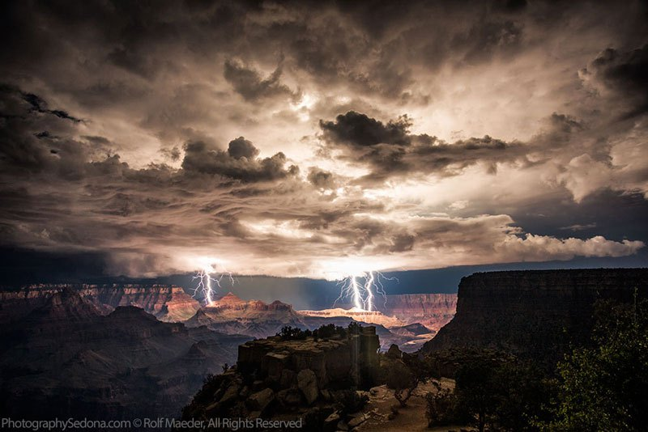
Storm Over Grand Canyon

Water
Of
Life

25 June 2017

W A T E R O F L I F E

Independent Christian Church—Conservative Lutheran Doctrine

Worship Service: 9:30 a.m. Bible Study: 10:45 a.m.

Larry Cooper, Pastor E-Mail address:
111 N. Ridge Road lcooper@wateroflife.cc
Coon Valley, WI 54623 Web Site:
Phone: (608) 452-2105 www.wateroflife.cc

* * * * * * * * * * * * * * * * * * * * * * * * * * *

Sermon Text: Song Of Solomon 7:4

Holy Violence

* * * * * * * * * * * * * * * * * * * * * * * * * * *

Song of Solomon 7:4 Thy neck is as a tower of ivory; thine eyes like the fishpools in Heshbon, by the gate of Bathrabbim: thy nose is as the tower of Lebanon which looketh toward Damascus.

Related Passages:

Genesis 3:14-15 14 And the LORD God said unto the serpent, Because thou hast done this, thou art cursed above all cattle, and above every beast of the field; upon thy belly shalt thou go, and dust shalt thou eat all the days of thy life: 15 And I will put enmity between thee and the woman, and between thy seed and her seed; it shall bruise thy head, and thou shalt bruise his heel.
1 Peter 5:8 Be sober, be vigilant; because your adversary the devil, as a roaring lion, walketh about, seeking whom he may devour:

Ephesians 6:10-18

10 Finally, my brethren, be strong in the Lord, and in the power of his might.
11 Put on the whole armour of God, that ye may be able to stand against the wiles of the devil.
12 For we wrestle not against flesh and blood, but against principalities, against powers, against the rulers of the darkness of this world, against spiritual wickedness in high places.
13 Wherefore take unto you the whole armour of God, that ye may be able to withstand in the evil day, and having done all, to stand.
14 Stand therefore, having your loins girt about with truth, and having on the breastplate of righteousness;
15 And your feet shod with the preparation of the gospel of peace;
16 Above all, taking the shield of faith, wherewith ye shall be able to quench all the fiery darts of the wicked.
17 And take the helmet of salvation, and the sword of the Spirit, which is the word of God:
18 Praying always with all prayer and supplication in the Spirit, and watching thereunto with all perseverance and supplication for all saints;

Matthew 11:12 And from the days of John the Baptist until now the kingdom of heaven suffereth violence, and the violent take it by force.

